**Name**: Deven Larisch  
**Hometown**: Riverton, UT  
**Major**: Human Nutrition, Emphasis in Allied Health  
**Engagement Track**: Leadership

**Title of Project**

The Rural Health Scholars program at SUU has been organizing trips to Las Vegas, the Four Corners area, the Dominican Republic, and Nicaragua for many years and they offer the opportunity to students to basically create and plan some of these trips. I am fortunate enough to have helped plan the Fall Break trip to Las Vegas.  The purpose of these trips are for pre-health students planning to go on to graduate school to gain experience in shadowing, patient/clinical exposure, and service among various diverse populations.  On this trip, we worked a lot with the homeless population in Las Vegas performing health screens, serving them food, etc.  As a trip leader, I made sure that organizations had been contacted, helped with travel, and guided students to have a good experience.  These trips are an awesome opportunity for these students to bump up their resumes and be more prepared for the graduate schools and healthcare careers ahead of them.

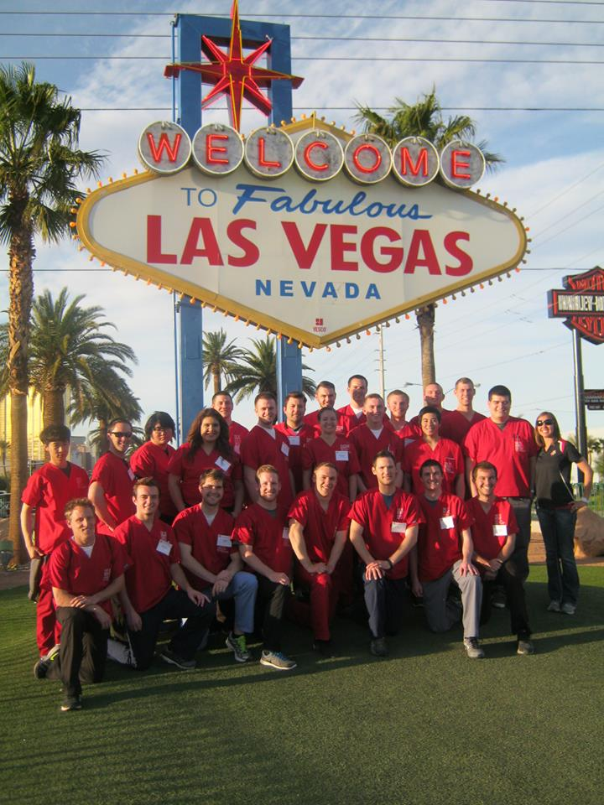Some of the organizations that we were able to work with included the Salvation Army, Shade Tree, Opportunity Village, and Catholic Charities. Students had many chances to sharpen their skills in health screening such as checking blood pressure, blood glucose, and vision. Before we left to Las Vegas, we held mini trainings to assure that everyone knew the basics of these tests and safety when doing health screens with these groups of people. One of the hardest parts of my project as a trip leader was to divide students and to get them to places on time in an efficient manner. It seemed easy to me at first, but turned out to be a challenge as the trip took place.

The inspiration for this project initially came from getting involved with a very similar trip to Las Vegas with Rural Health Scholars earlier that Spring. I received a scholarship to go on that Spring trip which was one week-long compared to the three-day trip in the Fall. I enjoyed my time on the trip and had ideas to improve the trip and make it a better experience for future students so I volunteered to become a trip leader for the trip in the Fall. I knew it was an opportunity that I could not pass up. I was able to learn many things on the trip as a leader that I could not learn as a participating student.

I stated earlier that one of the most difficult parts of leading the trip was associated with grouping and transporting students to the organizations in a timely manner. It can be a challenge to sort 25 students into groups that must fit into certain provided vehicles. Certain organizations would only allow a certain number of students to participate, especially if they were shadowing a physician. Most physicians will not allow more than 2-3 students to shadow at a time. Dealing with and pleasing the students can be another challenge because they may want to be place with or room with their friends. Many will not be enthusiastic with the organizations they got placed with.

It is easy to see how this project benefitted others than myself. It actually benefitted many different groups. Students from the university were able to benefit because they were able to develop skills and boost their resume for grad school. Homeless people at Salvation Army benefitted by receiving donations and a health screen from trained students. Women and children that were victims of domestic violence were benefitted at Shade Tree from our service of serving them food and organizing their donations as well as just sitting down to converse with them. Lower-class children who cannot afford school lunches benefitted from us helping make lunches at an organization called-three square. This trip is very service oriented and focused on underserved populations.

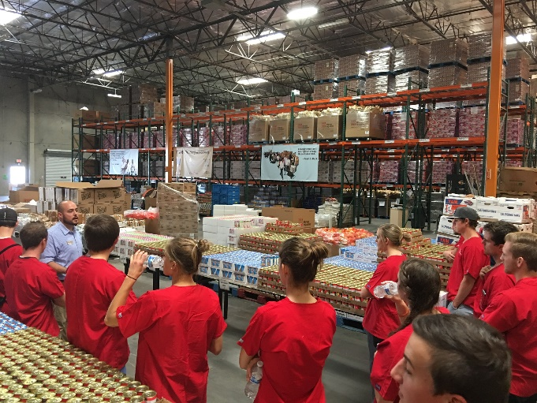 Even though it was a humanitarian service trip, I was also able to benefit greatly from participating and leading. The title itself names a great benefit: Cultural Immersion Trip. Living in Cedar City, I am not exposed to a huge diverse group of people. Traveling a few hours to Las Vegas can change that. As a future physician, I will have the opportunity to work with diverse populations and cultures and have to understand their needs or I may fail and upset some people. This trip has helped prepare me to work with certain groups of people that I was not familiar with at first. One of the other motivations for me to lead this trip was also to gain leadership experience that I can use in my future career as well. I now have improved my leadership skills in planning, organizing, and communicating to name a few. These will be useful skills when I work with a healthcare team in my future profession.

“Many of the [underserved individuals in these organizations] have many talents and deserve better lives.”

“…no matter how different we are, there are always more similarities. We just need to take the time to find them.”